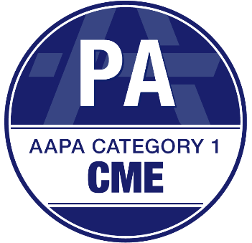
Your Logo Here

Your organizations name
certifies that
((NAME))
has earned and is awarded a total of
((CME NUMBER)) AAPA Category 1 CME Credits
as of
date

Your accreditation statement, as provided by your agreement.

Accreditor: American Academy of PAs (AAPA)
Credit Provider: Your organizations name

