AAPA 2021 HOD – PollEv Directions
Below are the directions to connect to Poll Everywhere for AAPA 2021 meeting. To be able to vote, you must be logged into Poll Everywhere so we suggest to test before the meeting. This document has 3 sections: Log In Directions, During Meeting Use, and Troubleshooting. We recommend that during the meeting you use another device since managing Zoom and Poll Everywhere can get crowded on smaller screens or single screen setups.
If you are experiencing an error or issues beyond what is covered in this document, please contact us at aapa21HODtechsupport@freemanco.com . We are here to help!

Log in Directions:
Since we used Poll Everywhere last November, we recommend to try signing in with your email associated with AAPA.
- Go to your Browser and type into the url - http://www.pollev.com/aapa21
We DO NOT recommend using the Poll Everywhere App on your cell / tablet. Its interface has many features that can make navigation longer and if not up-to-date can have errors in displaying content.

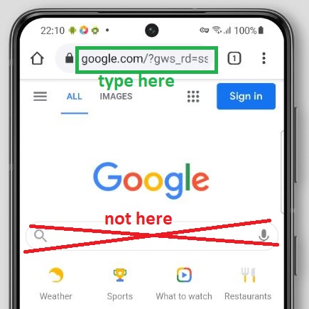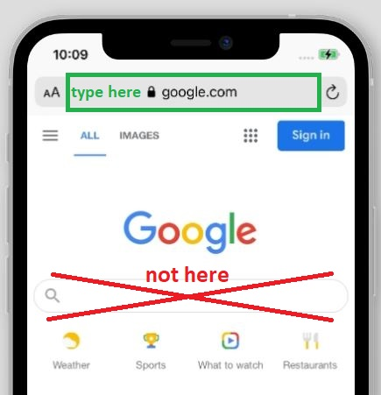

- Click Log in on the bottom of the left menu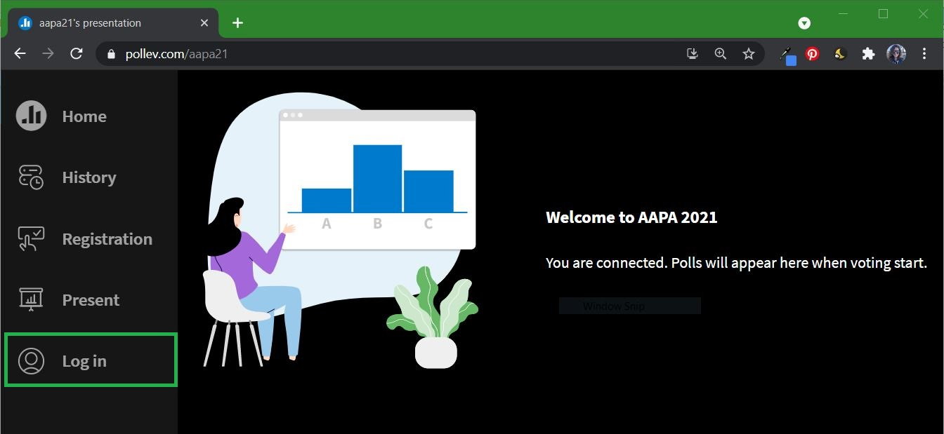

- Input your email (For .gmail users Sign in with Google or .mac users the Sign in with Apple)
Click Next, then put in your password and click Log In.
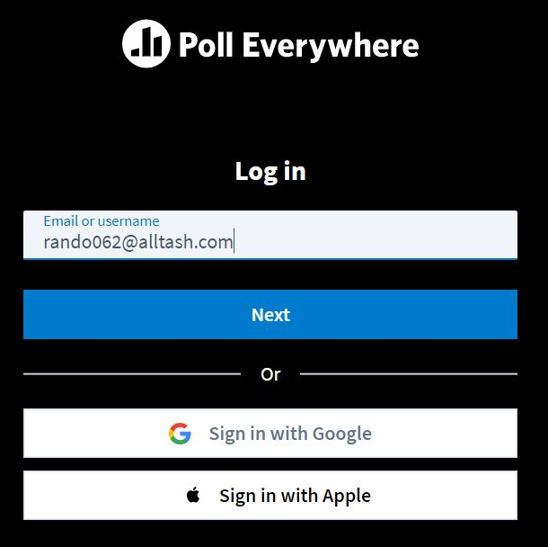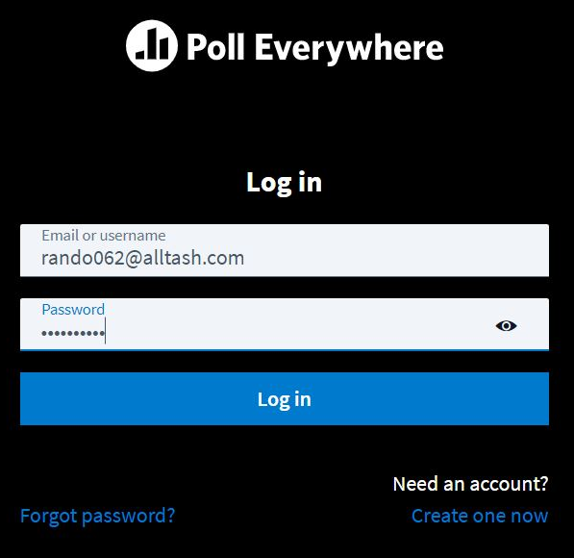
- (First time Logging In, if not you won’t see this screen) Choose to Accept terms and No to the promotional emails and click Update
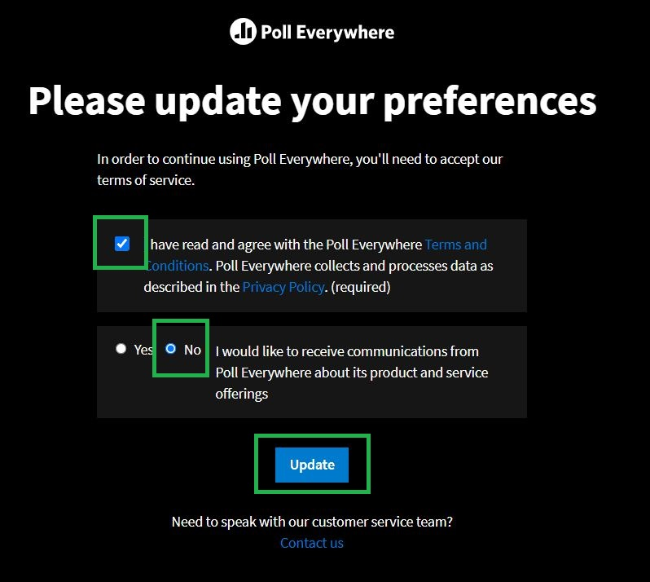

- Once logged you will be sent to PollEv.com so you will need to go back to our meeting by typing “ aapa21 ” in the username
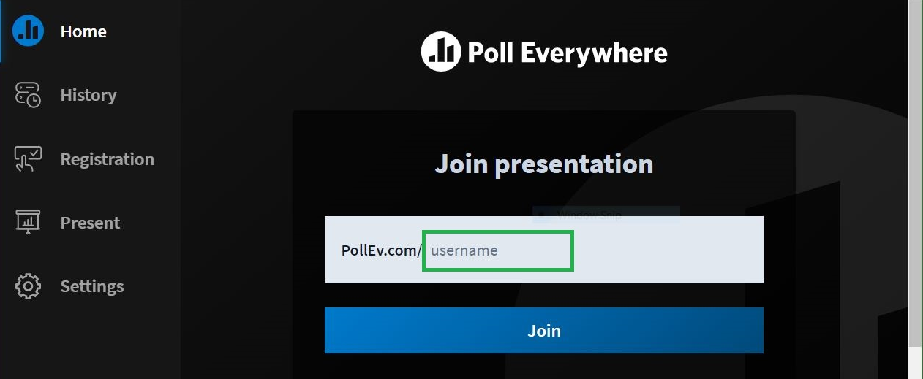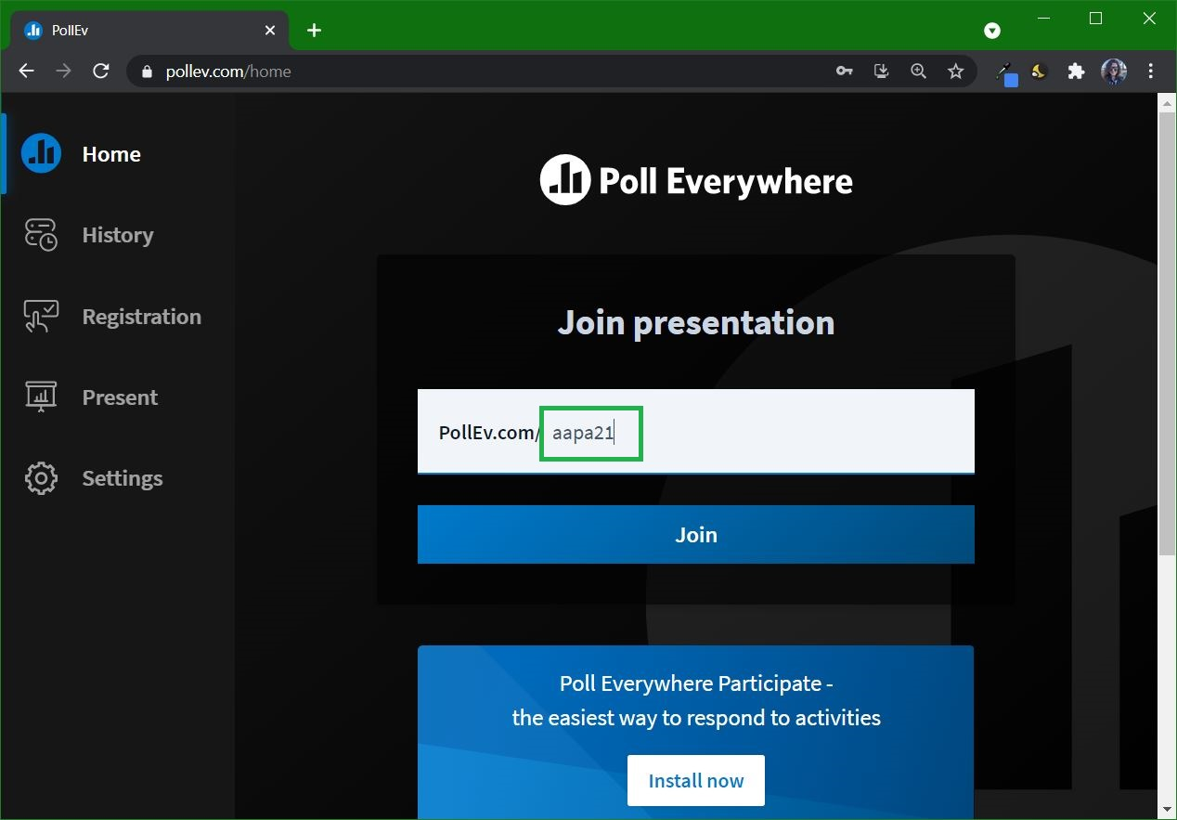
- If you see this page you’re back and logged in :D – (Not seeing Log In and seeing Settings means you’re logged in)
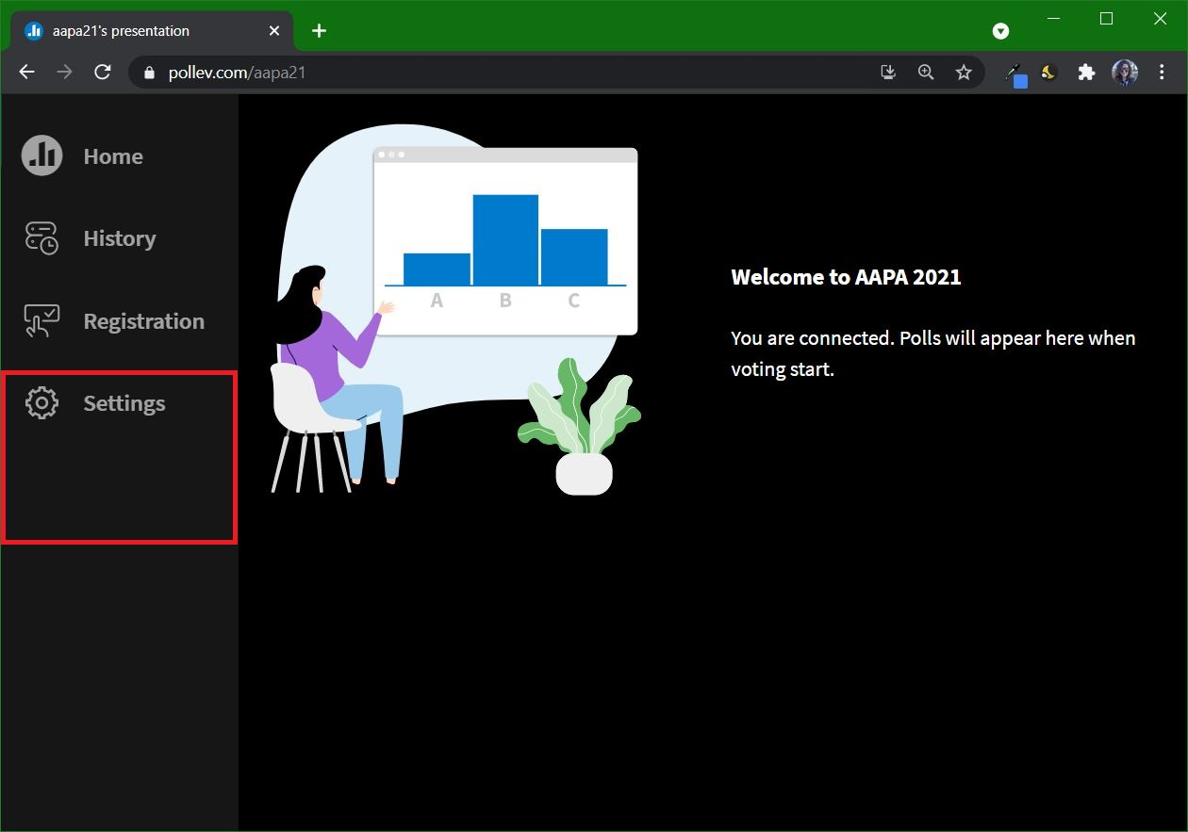
If you get Invalid Password, you can reset your password with “Forgot Password”. There’s a walk through this in Troubleshooting.
If you get Authentication Error you might need to use the Sign in with Google or Sign in with Apple.
If you are seeing another issue, the last section is troubleshooting where many answers are provided.
If you are experiencing an error or issues beyond what is covered in this document, please contact us at aapa21HODtechsupport@freemanco.com . We are here to help!

During Meeting Use:
After you’ve logged in, the page will look like this when no poll is active. You’ll notice there is no longer a “Log In” at the bottom of the left side panel. This means you’re logged in.

When a poll is activated it looks like the follow. Vote by clicking on Yes or No.
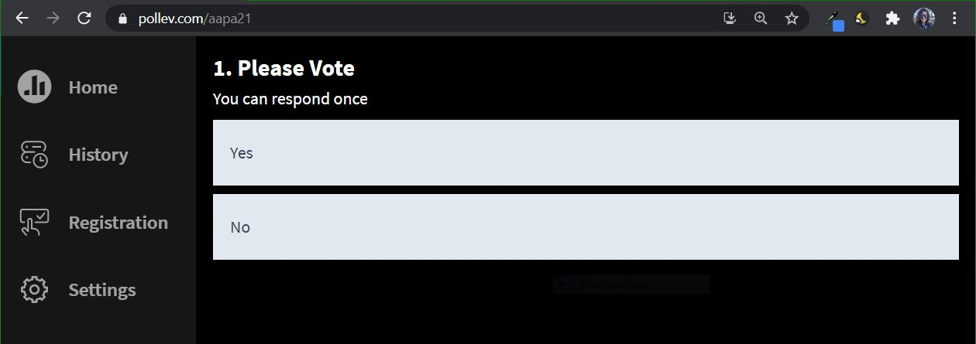
If you clicked on the wrong option you can use the clear button to re-vote. What ever you vote last is your vote and is only counted as one vote.
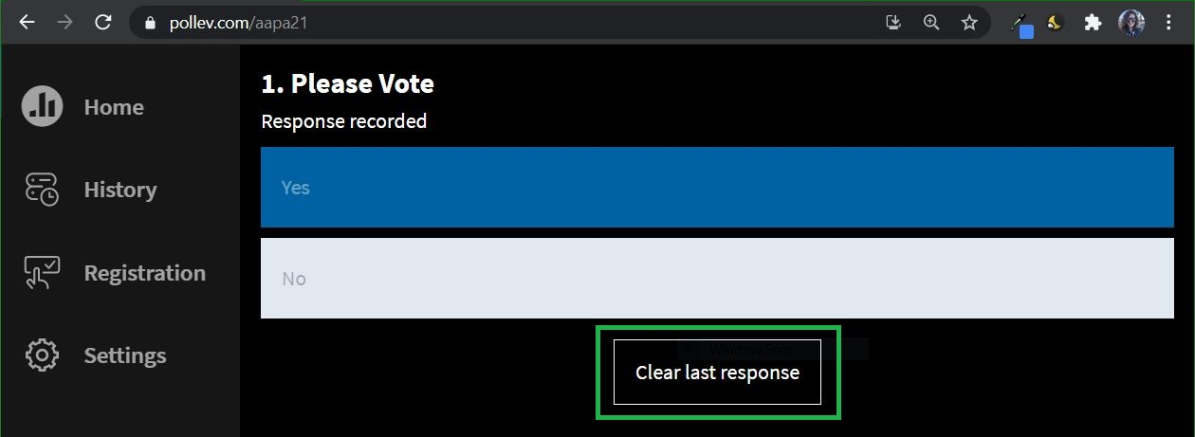

During the meeting you will be able to see the active vote on Zoom being opened. Depending on your browser settings if you do not see the new poll up displaying, you may have to click refresh to see the new poll. (We are numbering any polls that have the same text so you can tell them apart.)
Troubleshooting:
If you get Invalid Password:
- You can reset your password by clicking “Forgot Password”.
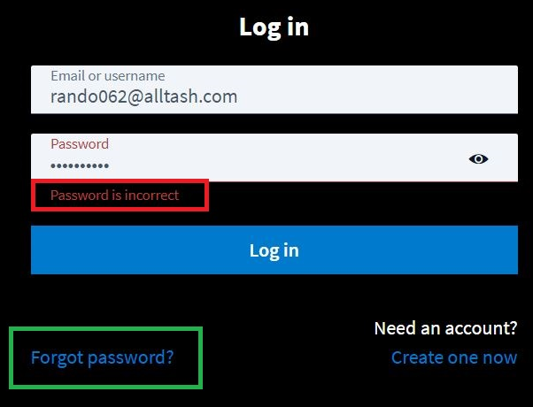
- Type in the email address you have associated with AAPA.
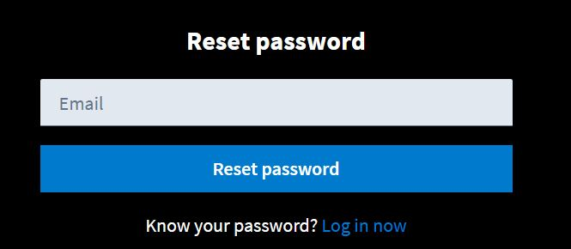
- You will get this confirmation text after you input your email address. You can close this page.
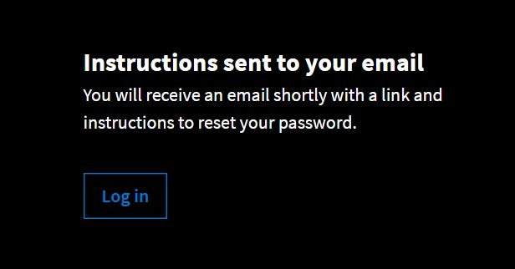
- In a minute you should receive an email from Poll Everywhere, if you do not see it check your SPAM folders. Open the email and click on the password Reset link.
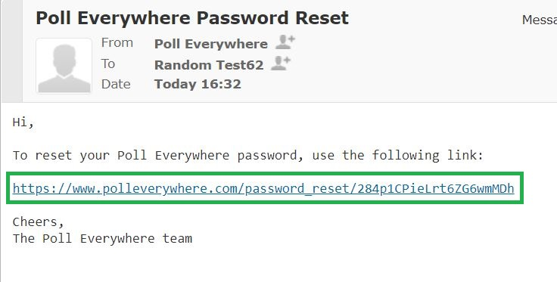
- The link will take you to this page and will say your email address. Type in password and click Save password and sign in.
- Once you saved your new password you’ll come to this page. CLOSE PAGE. DO NOT LOG IN ON NEXT PAGE or you will go to the Poll Everywhere backend page for creating polls and not to our meeting.
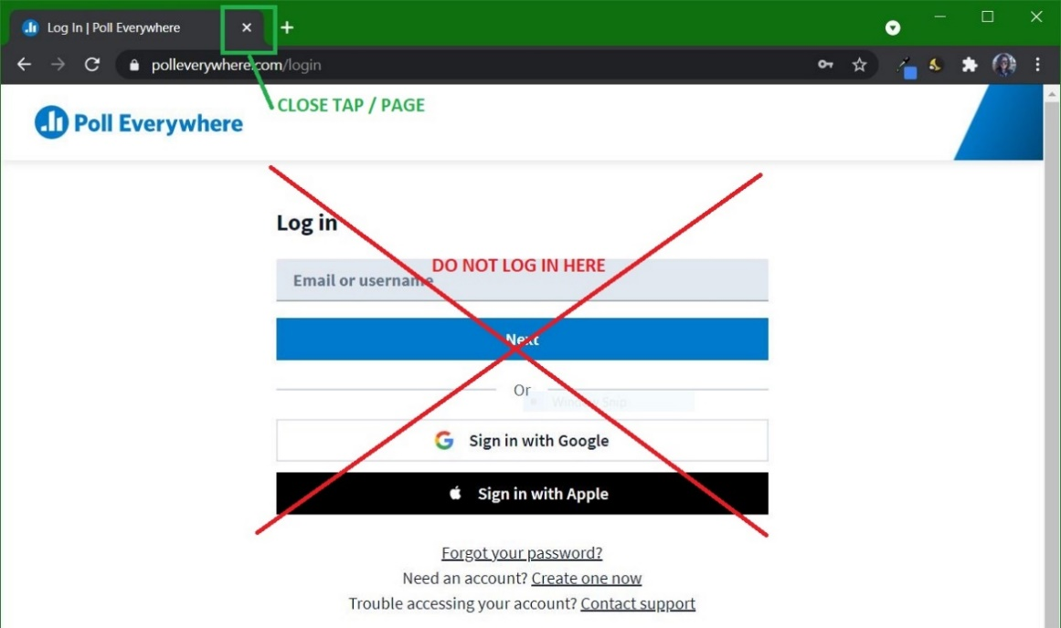

- Go back up to the Log In Directions at the top of this document and you can follow those steps to log in and participate in the voting.

If you get Authentication Error:
You might need to use the Sign in with Google because you have a google email address or Sign in with Apple if you have an apple email address. If you continue after trying these sign in options then please contact us at aapa21HODtechsupport@freemanco.com .
If your page looks like this after you log in: this means you logged into Polleverywhere.com instead of Pollev.com. Polleverywhere.com is the backend that allows you to make polling, Pollev.com is ONLY for VOTING. So go to http://www.pollev.com/aapa21 and if don’t see Log In on the left menu you are logged in. If it allows you to Log In then follow the directions from the top of this document and follow the Log in Directions.
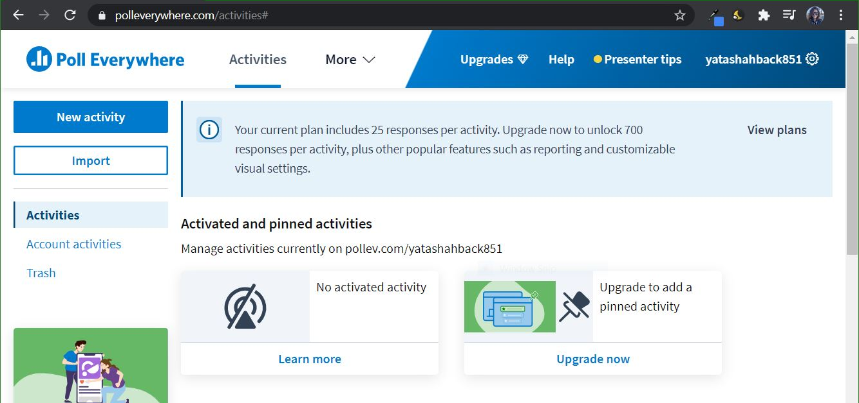

If you are experiencing an error or issues beyond what is covered in this document, please contact us at aapa21HODtechsupport@freemanco.com . We are here to help!

